SIGNPOSTplus Information Snippets
Northern Devon and Surrounding Areas
23rd January 2020

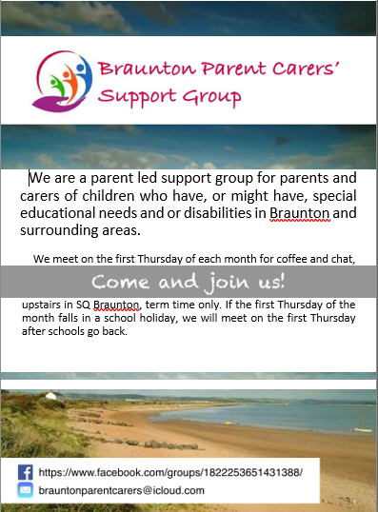

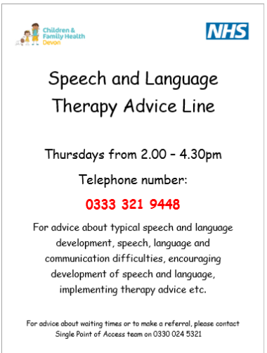

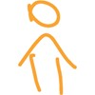
New Schools Exclusions Hub The charity Just for Kids Law has recently launched a new project that will increase the advice and representation for children across
England facing exclusion from school. The School Exclusions Hub is an online resource featuring step-by-step guides with links to relevant legal guidance and template documents to handle every stage of the school exclusion process. Find out more here: https://justforkidslaw.org/schoolexclusions-
hub?utm_source=Facebook&utm_medium=social
&utm_campaign=SocialSignIn

Eyelander is an online game for young people with partial vision loss caused by brain injury. The game was designed by WESC Foundation – The Specialist Centre for Visual Impairment. It includes gamified visual search training that can help improve the player’s ability to find objects in cluttered settings. You can play the game on a tablet or with a mouse and keyboard, on most modern browsers. https://www.eyelander.co.uk/

NAS Young Ambassadors are a group of young autistic people, aged 16 to 21 who raise awareness of the challenges autistic young people face. The Young Ambassador Group will meet at least four times a year in London, where you will:
- Learn how social change can happen
- See how to influence the media and decision-makers
- Collect and share people’s stories
- Create amazing videos to grab supporter’s attention
- Run your own amazing social media campaign
The NAS will pay for travel and food at Young Ambassador meetings, as well as any other reasonable expenses to be agreed.
Find out more and apply to become an Ambassador here

TheSpectrum Magazine January 2020 now available to download: https://www.autism.org.uk/aspergerunited
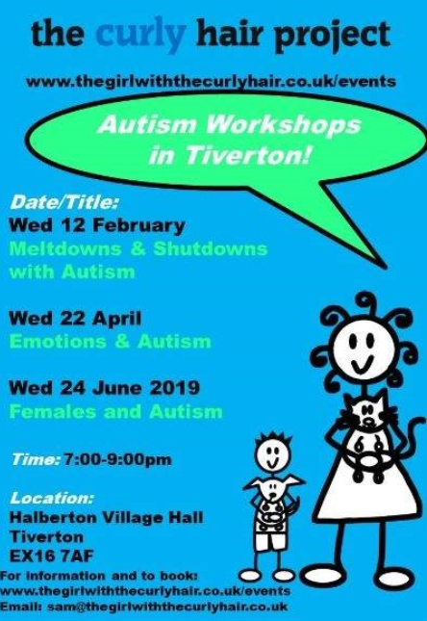

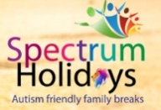
Spectrum Holidays was started by Sophia and Malcolm after years of struggling to find suitable holiday accommodation for their son, Luca who is autistic. They specialise in UK based autism friendly holiday cottages, caravan and lodges. They also offer support to families in their holiday preparation through the use of visual resources and social stories. Find out more at their website: www.spectrum-holidays.com or Facebook page: https://www.facebook.com/spectrumholiday/

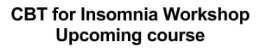
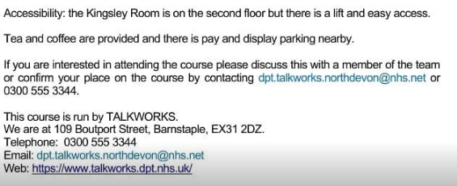
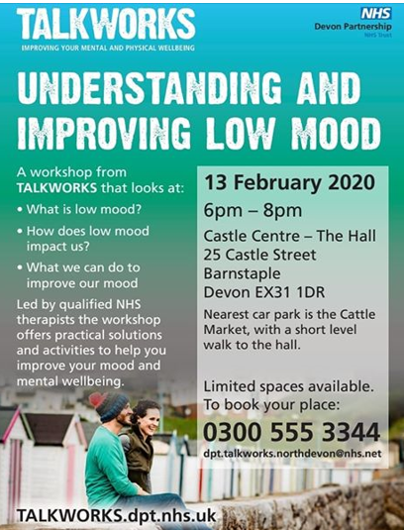

SEND Website Improvements. Devon County Council would like to make their special educational needs and disabilities (SEND) website easier to use, so you can access the information you need without having to search around. They need volunteers to take part in some user research so they can check the changes they are planning to make to the website are the right ones. The survey will take 5 minutes to complete and can be found here

We always welcome feedback…..
Let the SIGNPOSTplus team know if you have any opinions on what works and what doesn’t work with our information sharing. If you have any ideas for improvements or if you have anything else you would like to share.

Find us on Facebook…..like the SIGNPOSTplus page for regular updates on all things related to children with additional needs.

An archive of recent snippets can be found at the SIGNPOSTplus page on the Children and Family Health Devon website

If you no longer wish to receive these bulletins please let me know and I will remove your details from the mailing list.

Disclaimer: The information in these snippets is for general information purposes only and is provided by various organisations. Whilst we endeavour to keep the information up to date and correct, we make no representations or warranties of any kind, express or implied, about the completeness, accuracy, reliability, suitability or availability with respect to the information, products, services or otherwise included in this publication for any purpose. Any reliance you place on such information is therefore strictly at your own risk.
