SIGNPOSTplus Information Snippets
Northern Devon and Surrounding Areas
13th February 2020

Disability Football - 2020 ENGLAND TALENT DAY. Taking place on Saturday 6th June 2020 from 11.30am – 2pm at Devon County FA, Coach Road, Newton Abbot, TQ12 1EJ. This opportunity is only open to players aged 7 – 16 years within the below impairment groups:
- Amputee (male)
- Blind (male and female)
- Cerebral Palsy (male)
- Deaf (male and female)
- Partially Sighted (male)
Players can be nominated or apply via the below Survey Monkey website link
https://www.surveymonkey.co.uk/r/VMWRG8T
For further information or if you have any questions, please contact the Ashley Harris, Devon FA Disability Football Development Officer by email: (ashley.harris@devonfa.com) or Tel: (01626 323560).
You can find your local youth inclusive football club here

Afasic. Download a FREE series of quick and easy ‘Handy Hints’ guides to helping children and young people who have speech and language problems.
https://www.afasic.org.uk/resources/free-downloads/recognising-a-problem-and-getting-help/

ARC Inclusive Tennis Festivals in Bideford. The February Festival will be taking place this Saturday (15th), 2pm-4pm. Sessions cost £5 (first session is free) and open to children aged 4+ with a learning or physical disability. Find out more at: http://www.atlanticracquetcentre.co.uk/ To book email: lottie@atlanticracquetcentre.co.uk

Unique have just published two quick read general information guides to provide a quick explanation of chromosomal deletions and duplications. You can view and download them for free here:
deletions and microdeletions and duplications and microduplications View Unique’s full range of publications here: www.rarechromo.org/disorder-guides

The PDA Society have released a video which combines experiences kindly shared by children, young people and adults to help raise awareness of how demand avoidance can present in the PDA profile of autism.
The video can be viewed on YouTube - https://youtu.be/CCsfKxyuH1I
For further information visit the website - www.pdasociety.org.uk

BISnet Physical Strength and Movement for Young Autistic People ‘Muscle for your Mind Programme’. BISnet is delighted to announce its latest project in conjunction with Howard's Health and Fitness. Strength training and physical movement provide all kinds of incredible benefits for everybody. Self-confidence, bodily awareness and interoception, relief of tension, stress and anxiety. However, accessing busy gyms can be daunting for many young people on the Autistic Spectrum. Even the most qualified of Personal Trainers may not always know enough about how Autistic people process the world, to adapt physical exercise programmes to suit them. The Muscle for Your Mind Programme will take place at: Benchmarks Gym, Cofton Road, Marsh Barton on: Friday 21st Feb and then every other Friday from then onwards. From 3pm until 4.30pm. The programme is limited to 6 spaces, this will ensure a bespoke, person centred approach to the session, whilst still gently encouraging socialisation and peer bonding. Each session is charged at £30 per person for 90mins and is for young people between the ages of 12 - 18. You can sign up for a discounted 6 sessions rate of £150.
To discuss further or book your young person onto the course please contact Sam on: sam.harris@cedaonline.org.uk or direct message the BISnet Facebook page.

Syndromes Without A Name - Do you work in a school setting and support pupils that have undiagnosed genetic conditions? SWAN have produced an information leaflet specifically designed to help teachers and schools support children and families affected by a syndrome without a name: https://www.undiagnosed.org.uk/…/information-for-teachers-…/

Art Camp is back with a twist this February Half Term!
Art Camp is back in the February Half Term at Umberleigh Academy - this time they are joining forces with Lego Sense to offer Art & Lego camp! Children can choose to do a whole day of art, a whole day of Lego engineering, or a bit of both throughout the day!
Wednesday 19th February, 9am - 3.30pm for 4 - 12 year olds, any ability and inclusive of additional needs. Cost for the day £30. Book a place here:
http://oscaw.com

Apple Tree Farm - Animal Care Sessions. The current group running on Wednesdays from 1.30pm-3pm has been so successful that they will continue to run them every term - booking is now open for next term. There is the possibility of adding an extra group on a Wednesday, 12:00 to 13:30, should there be enough interest. Sessions are suitable for children aged 7+ and not within the educational system. Find out more Apple Tree Farm and express and interest in the sessions here: http://www.appletreefarmservices.co.uk/

Constipation and Autism. Dr Eve Fleming, ERIC Trustee, special needs expert and continence specialist, looks at the links between children on the autism spectrum and constipation. While many children on the autism spectrum have no difficulties with constipation, it does often occur. This can result in delay in achieving reliable bowel and also bladder control. In addition it can cause a great deal of discomfort, and anxiety for both children and their parents and carers. Read more here

Contact DLA Ask the Experts Q&A. You can view a summary of the main questions asked in the recent online session here
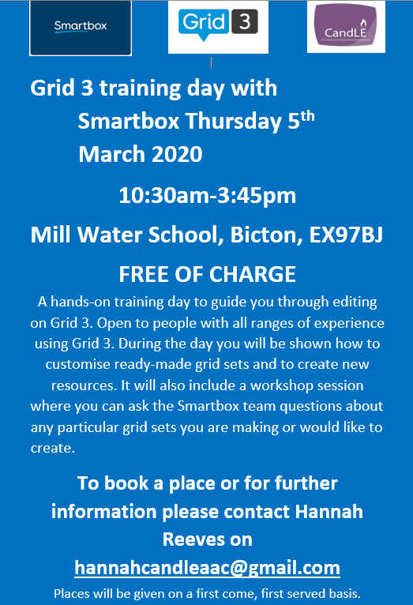

Family Fund iPad training
The Family Fund digital skills training is free to families with disabled or seriously ill children and young people and supports families to get the most out of their iPads or Android tablets. Training covers whatever families ask for, the most popular being:
-Customising your iPad to address any vision, hearing, motor and learning needs of your child.
-Keeping your child safe online with features to limit your child’s access to apps or the internet.
-Locating and accessing other help or information you might need.
Training can be delivered in three different ways to suit you; One-to-one training, Workshops or
Group training. Find out more and read how other families, who have had training, feel about our digital skills programme and the difference it made to them here

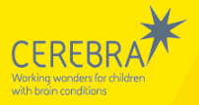

Learning Disability, Autism and Internet Safety - A guide for parents. Cerebra’s guide outlines some suggestions to help you limit the risk of your child having negative experiences online and understand what action can be taken if they do. This guide also suggests resources that will help your child get the most out of the Internet. Download a copy here
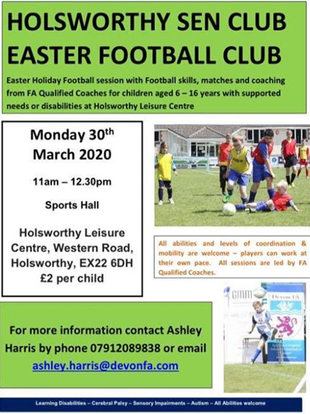

Are you in a Parent Support Group?
Contact have recently updated their Group Action Pack for Parent Support Groups, and now you can request them to email you all eight parts in one download.
Whether you're setting up a new support group or already running one, Contact have a range of resources to help, and can give you guidance on how to run your group. The Group Action Pack is packed with tips and sources of specialist advice for Parent Support Groups. It covers issues ranging from how to start a group and hold meetings to charity registration, publicity and fundraising. Order your copy here
United Response – Easy News is the first news magazine designed to be accessible for people with learning disabilities, aimed to encourage discussion around news stories and keep readers informed about the world around them. Read the latest issue and sign up to receive the magazine direct to your inbox here

Sensory Spectacle have a wide range of short videos on their YouTube channel including the ‘Homelife' series, answering your everyday questions relating to sensory processing disorder. There are also lots of sensory based activity ideas. View the range here
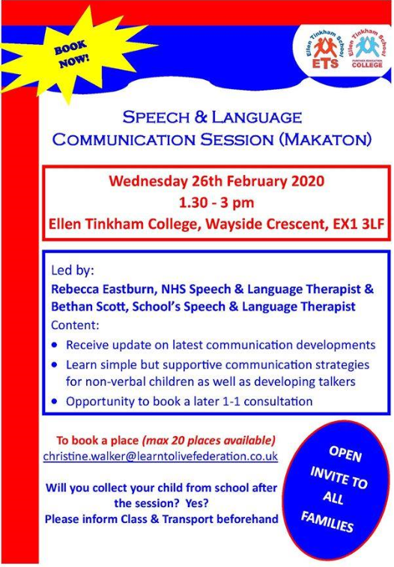

We always welcome feedback…..
Let the SIGNPOSTplus team know if you have any opinions on what works and what doesn’t work with our information sharing. If you have any ideas for improvements or if you have anything else you would like to share.

Find us on Facebook…..like the SIGNPOSTplus page for regular updates on all things related to children with additional needs.

An archive of recent snippets can be found at the SIGNPOSTplus page on the Children and Family Health Devon website

If you no longer wish to receive these bulletins please let me know and I will remove your details from the mailing list.

Disclaimer: The information in these snippets is for general information purposes only and is provided by various organisations. Whilst we endeavour to keep the information up to date and correct, we make no representations or warranties of any kind, express or implied, about the completeness, accuracy, reliability, suitability or availability with respect to the information, products, services or otherwise included in this publication for any purpose. Any reliance you place on such information is therefore strictly at your own risk.

